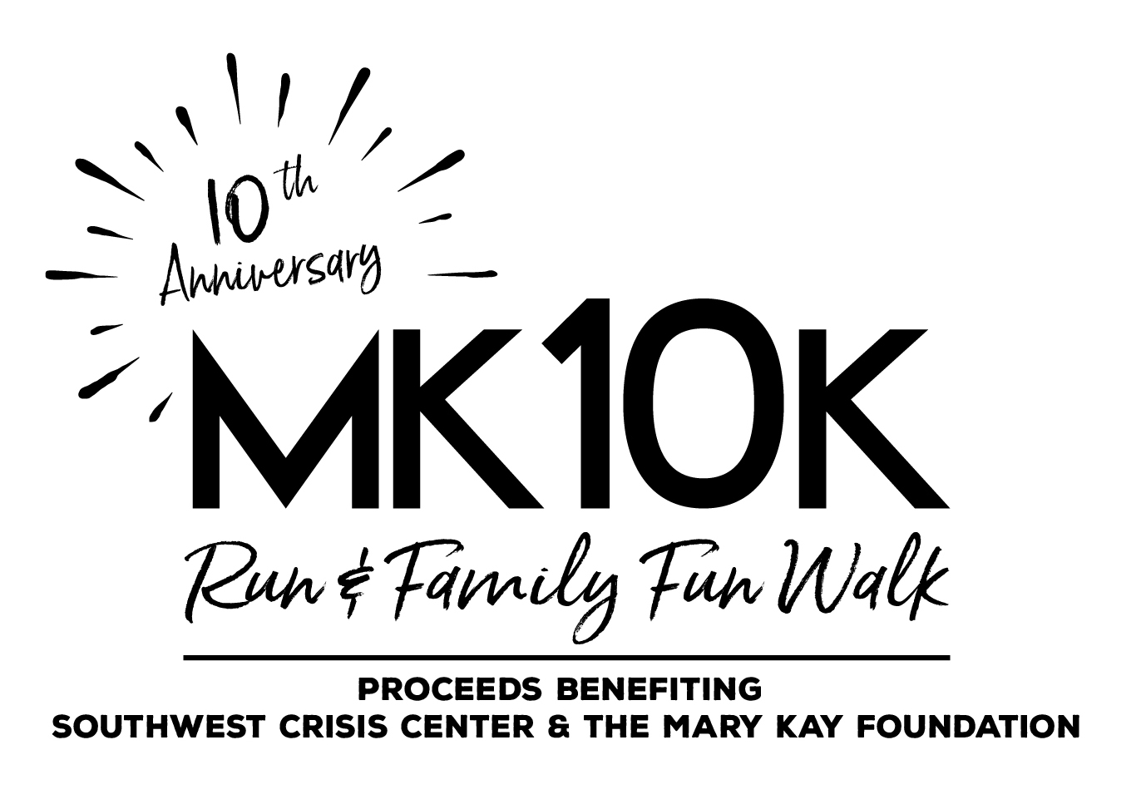
MK 10K Run & Family Fun Walk
Registration Form
Saturday, August 4, 2018
Check-In/On-Site Registration: 8:00 a.m.
Nobles County Fairgrounds,
Worthington, Minnesota

First Name ____________________________ Last Name ___________________________________________
Date of Birth (Month/Date/Year) _____________________________
Address___________________________________________________________________________________
City_______________________________________________State__________Zip_______________________
Phone___________________________________Email_____________________________________________

Entry Fee
___ $40 - 10K Relay (If received before July 28, 2018) ___ $50 - 10K Relay (starting July 28, 2018)
___ $30 - 10K Individual (If received before July 28, 2018) ___ $35 - 10K Individual (starting July 28, 2018)
___ $15 - 2 Mile Fun Walk (If received before July 28, 2018) ___ $20 - 2 Mile Fun Walk (starting July 28, 2018)
Shirt Size (circle one) Youth M Youth L Adult S Adult M Adult L Adult XL Adult XXL
WAIVER: I hereby release the race director, co-directors, Nobles County Fair Board, and all other sponsors and/or individuals from responsibility from any injuries or damages I may suffer as a result of my participation in this event. I have read the entry information provided and certify my compliance by my signature below. I also understand the entry fees I pay are NONREFUNDABLE. I attest and certify that I have full knowledge of the risks involved with this event and am physically fit and sufficiently trained to participate in this event.

Signature______________________________________________________________________________________________________________
(by parent or guardian if participant is under 18 years old)
*****************************************************************************
Detach & Mail this form to:
Southwest Crisis Center – MK10K
PO Box 111
Worthington, MN 56187
Please make checks payable to: Southwest Crisis Center

Race Details: The Nobles County Fairgrounds is located one block north of Oxford Street on Stower Drive in Worthington. The MK 10K Run & Family Fun Walk will begin and end on the north end of Nobles County Fairgrounds near the grandstand. Check-In/On-Site Registration begins at 8:00 a.m. All participants must check-in at the MK 10K registration table prior to the start of the event.

