Little Wolf Adventure Triathlon Course Info and Maps

Course Info and Maps:
The event starts and ends at Manawa Area Veterans Freedom Park. (Beach Road Manawa, WI)
The event start will be in a wave format with waves of 10 participants starting every 5 minutes.
Participants need to be at the park and ready to race 30 minutes to their race start time.
Participants will be called to the on-shore staging area 20 minutes before their start time.
At 15 minutes to the start time, Participants will be allowed in the water to warm up.
At 10 minutes to the start time, participants will move to the in-water staging area.
At 5 minutes to the start time, participants will move to the kayak start line.
Participants need to be at each phase of the start at the appropriate time.
Anyone that misses the start time will be moved to the last wave of the day.
No one will be allowed to move to earlier start times.

Kayak Course, 2.2k (1.4 miles):
Life jackets must be properly worn while in the water.
The kayak course starts just off shore from the Manawa Area Veterans Freedom Park.
Be courteous to other paddlers. No striking other paddlers or boats with your paddle or kayak.
The course heads north to the shoreline and follows the shoreline around the lake and peninsula then heads towards the Little Wolf County Park.
Kayakers will land at the west boat landing.
Participants will paddle to the shoreline, safely exit the kayak, and pull the boat to shore.
Paddles and life vests will be placed in the kayak, NOT in the bike/run transition area.
Volunteers will take the kayak to the kayak pick-up area.
Participants will continue up the hill to the transition area and begin the bike segment.
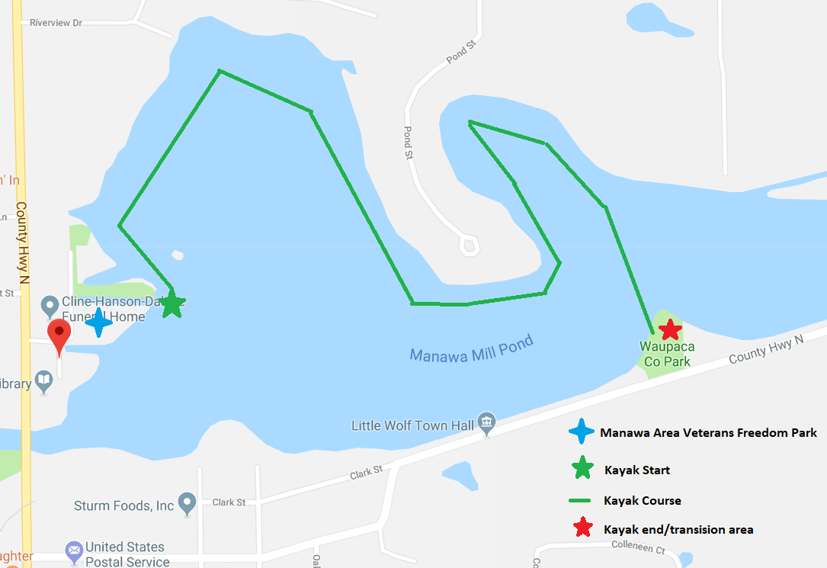

Bike Course, 18.5K (11.5 miles):
Bike Helmets are required to be properly worn while on the bike course.
Observe all traffic laws. Safety is the main concern.
Be courteous to other participants.
Participants must walk the bike while in the transition area.
There will be a bike mount/dismount area to mount and dismount the bike.
As you exit the transition area, you will pass under the first timing arch. This will end the paddle time and start the bike time.
Participants will take a right out of the County Park to begin the bike course.
The course follows County Road N to Union Street.
From Union Street, participants will take a left on Grove street and continue to 4th Street.
At 4th street, take a left to ride past the high school and continue Garrity Road.
This is the first hill climb. Follow Garrity road past Highway O for a short downhill section.
The course follows Garrity road around the corner and up the hill to Nicolai Road.
Take a right at Nicolai Road. This is a nice fast and flat section leading to Highway T.
At Highway T, take a left and continue to Island Road.
Take a left onto Island Road for a short flat section to begin the third and most challenging hill climb.
Continue straight on County Road N up the fourth and final hill climb.
Then participants will continue onto County Road N along the Little Wolf River back to Little Wolf Park.
Sections of County Road N are rough and cracked. PLEASE RIDE WITH CAUTION.
Dismount the bike in the mount/dismount area continue to the transition area to begin the run.
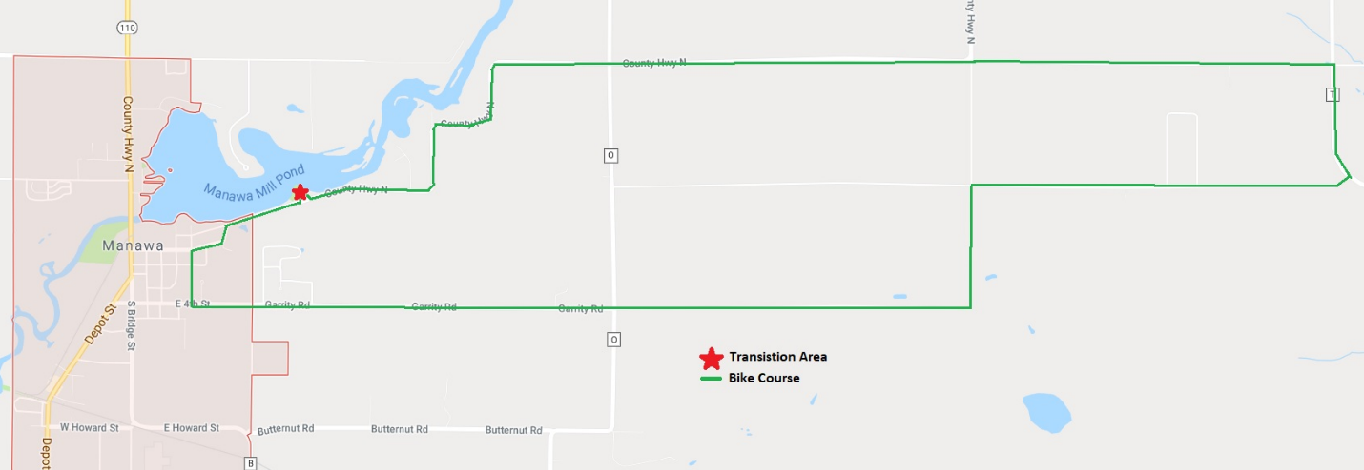

Run Course, 5K (3.1 miles):
Observe all traffic laws. Safety is the main concern.
Be courteous to other participants.
As you exit the transition area, you will pass under the timing arch. This will end the bike time and start the run time.
Participants will take a right out of the County Park to begin the run course.
The course follows County Road N to the Little Wolf Town Hall. Then takes a left to start towards the Patrick Wade Memorial trail. This is an approximate .1 miles grass section going uphill to Colleen Ct.
Take a left on Colleen Court and follow Colleen Ct and Esther Drive towards Garrity Rd.
Cross Garrity Road and run the Patrick Wade Memorial Trail to Beech St. The trail is crushed gravel/dirt and is approximately .5 miles long.
Cross Beech St and take the paved Dewey Carl Trail along Beech St and County Rd B to Bridge Street.
Follow Bridge Street north to Beach Road / the Manawa Area Veterans Freedom Park and the finish line!

